**E-commerce final**

1. **Multiple choice question**
2. Snapchart’s Lenses feature is an example of which of the following?
3. Virtual reality
4. Artificial intelligence
5. Augmented reality
6. Chatbot
7. All of the following are steps one can take to right-size a website’s hardware platform and meet demands for service except:
8. Scaling hardware vertically
9. Scaling hardware horizontally
10. Replacing static pages with dynamically generated pages
11. Improving processing architecture
12. Which of the following is an example of an on-demand service company?
13. YouTube
14. Airbnb
15. Tumblr
16. Facebook
17. The transport layer of TCP/IP is responsible for which of the following?
18. Placing packets on and receiving them from the network medium
19. Addressing, packaging, and routing messages
20. Providing communication with the application by acknowledging and sequencing the packets to and from the application
21. Providing a variety of applications with the ability to access the services of the lower layers
22. Stickiness is an important attribute for which of the following revenue models?
23. Advertising revenue model
24. Subscription revenue model
25. Transaction fee revenue model
26. Affiliate revenue model
27. All of the following are issues facing Pinterest except:
28. Copyright infringement
29. Inability to retain users
30. Spam
31. Scams
32. Which of the following statements is not true?
33. Information asymmetries are continually being introduced by merchants and marketers
34. Intermediaries have not disappeared.
35. Overall transaction costs have dropped dramatically
36. Brands remain very important in e-commerce
37. The protocol that enables the transmission of voice and other forms of audio communication over the internet is called
38. VoIP
39. IPTP
40. VTP
41. IP
42. In general, the key to becoming a successful content provider is to
43. Own the content being provided
44. Own the technology by which content is created, presented, and distributed.
45. Provide online content for free
46. Provide other services as well as online content.
47. All of the following are characteristics of HTML5 except
48. A video element that replaces plug-ins such as Flash, QuickTime, and RealPlayer
49. Use of CSS3
50. Ability to access built-in functionality of mobile devices, such as GPS and swiping
51. Support for digital rights management
52. Over the past decade, the number of exchanges has
53. Greatly increased
54. Diminished sharply
55. Stayed about the same
56. Increased slowly but steadily
57. The internet layer of ICP/IP is responsible for which of the following?
58. Placing packets on and receiving them from the network medium
59. Addressing, packaging, and routing messages
60. Providing communication with the application by acknowledging and sequencing the packets to and from the application
61. Providing a variety of applications with the ability to access the services of the lower layers
62. An IPV4 address is expressed as a
63. 32-bit number that appears as a series of four separate numbers separated by semicolons
64. 64-bit number that appears as a series of four separate numbers separated by semicolons
65. 64-bit number that appears as a series of four separate numbers separates by periods
66. 32-bit number that appears as a series of four separated number separated by periods
67. Building which of the following is the most expensive path to creating a mobile presence?
68. Native app
69. Mobile website
70. Mobile web app
71. Hybrid HTTP
72. Django is based on which of the following?
73. PHP
74. Python
75. Perl
76. Ruby on Rails
77. Which of the following is not a community provider?
78. LinkedIn
79. Facebook
80. Blue Nile
81. Pinterest
82. Which of the following is not one of the basic business objectives for an e-commerce site?
83. Display goods
84. Execute a transaction
85. Provide production and supplier links
86. Optimize system architecture
87. Which element of the business model refers to the presence of substitute products in the market?
88. Value proposition
89. Competitive environment
90. Competitive advantage
91. Market opportunity
92. Which of the following is a set of rules for transferring data?
93. Protocol
94. Packet
95. Router
96. IP address
97. Which of the following would you use to verify that links on web pages are valid?
98. HTTP
99. FTP
100. Data capture tools
101. Site management tools
102. Which of the following companies use a transaction fee revenue model?
103. Yahoo
104. E*Trade
105. Twitter
106. Birchbox
107. The major technologies use with wireless local area networks are
108. Wi-Fi and Bluetooth
109. Wi-Fi and WiMax
110. Bluetooth and 2G
111. WiMax and 3G
112. Which of the following are specialized computers that transmit message parcels along available Internet communication paths and on to their destinations?
113. routers
114. Web servers
115. IP servers
116. Packet servers
117. All of the following are considered a precursor to e-commerce except
118. The development of the smartphone
119. Baxter healthcare’s PC-based remote order entry system
120. The French Minitel
121. The development of Electronic Data Interchange (EDI) standards
122. The early year of e-commerce are considered
123. The most promising time in history for the successful implementation of first mover advantage
124. An economist’s dream come true, where for a brief time consumer had access to all relevant market information and transaction costs plummeted
125. A stunning technological success as the Internet and the Web increased from a few thousand to billions of e-commerce transactions per year
126. A dramatic business success as 85% of dot-coms formed since 1995 became flourishing businesses
127. Which of the following involves testing a site program’s modules one at a time?
128. System testing
129. Acceptance testing
130. Unit testing
131. Implementation testing
132. Which of the following is a characteristic of the consolidation phase of e-commerce?
133. Predominance of pure online strategies
134. Emphasis on revenue growth versus profits
135. Brand extension and strengthening becomes more important than creating new brands
136. Shift to a technology-driven approach
137. The existence of many competitors in any one market segment may indicate
138. An untapped market niche
139. The market is saturated
140. No one firm has differentiated itself within that market
141. A market that has already been tried without success
142. The seam is an example of a(n)
143. Private industrial network
144. Exchange
145. Industry consortium
146. E-distributor
147. Which elements of the business model addresses what a firm provides that other firms cannot?
148. Competitive environment
149. Competitive advantage
150. Market strategy
151. Value proposition
152. **File in the blank**
153. A ………………. Marketplace supplies products and services of interest to particular industries
154. Perfect
155. Differentiated
156. Horizontal
157. Vertical
158. A ……………… is a networked business ecosystem that coordinates a firm’s suppliers, distributors, and delivery firms with its own production needs using an Internet-based supply chain managements system
159. Value chain
160. Value system
161. Value web
162. Business strategy
163. A strategy designed to compete within a narrow market of product segment is called a ……………. Strategy
164. Scope
165. Differentiation
166. Commoditization
167. Focus
168. ……………. Technologies are technologies that enable the incremental improvement of products and service
169. Sustaining
170. Differentiating
171. Disruptive
172. Commodity
173. Innovative entrepreneurs and their business firms that destroy existing business models are referred to as …………..
174. Crowd funders
175. Venture capitalists
176. Disruptors
177. **Answer the Question**
178. List and briefly explain the main types of e-commerce.

The main type of e-commerce are:

* Business-to-Consumer (B2C): in which online businesses attempt to reach individual consumers;
* Business-to-Business (B2B): in which focus on selling to other businesses;
* Consumer-to-Consumer (C2C): which provides a market in which consumers can sell goods to each other;
* Mobile e-commerce (m-commerce): which refers to the use of wireless digital devices to enable online transactions;
* Social e-commerce: which is commerce enabled by social networks and online social relationship;
* Local e-commerce: which is focused on engaging the customer based on his or her geographical location;

1. Which academic disciplines have a technical approach to e-commerce? What is each discipline interested in to contribute to the overall success of e-commerce?

* Computer scientists, operations management scientists, and certain technical groups within the information systems discipline all take a technical approach to e-commerce. Computer scientists are interested in e-commerce as an exemplary application of Internet technology. They are concerned with the development of computer hardware, software, and telecommunications systems, as well as standards, encryption, and database design and operation. Operations management scientists are primarily interested in building mathematical models of business processes and optimizing these processes. They are interested in e-commerce as an opportunity to study how business firms can exploit the Internet to achieve more efficient business operations. Technical groups within the information systems specialty focus on data mining, search engine design, and artificial intelligence.

1. 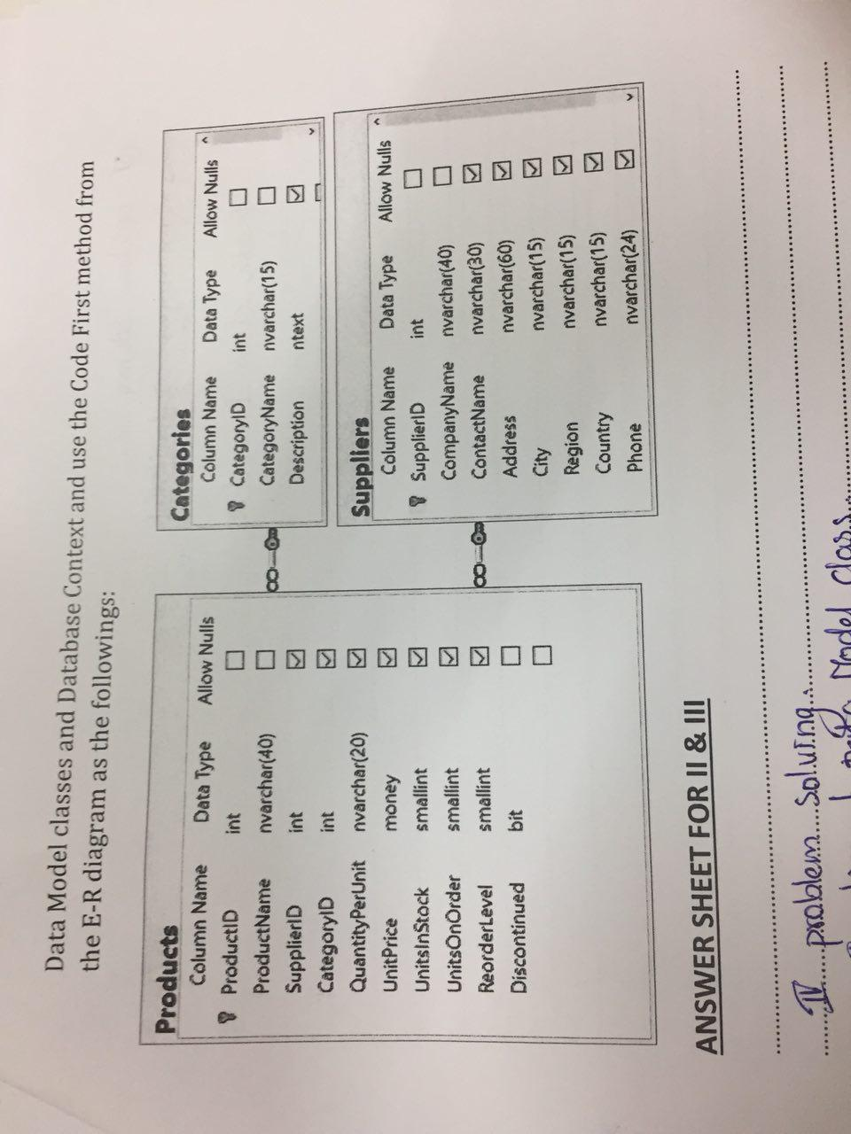**Problem solving**

You are an e-commerce developer with ASP.Net core and Agular, and you have been tasked to develop the new eCommerce project. You create new ASP.Net core with Angular project and connect to SQL-UPCom SQL Server. Implement the Data Model classes and Database Context and use the code first method from the E-R diagram as the following.